CST 2309: Lab 10

Using the instructions in Chapter 2, you will create a program that calculates the total cost of photography provided by Fan Trick Fine Art Photography

**Include address bar in all screenshots**

1. Add a screenshot of the js02.html file opened in a browser window. Refer to Step 4 on page 65 Figure 2-26

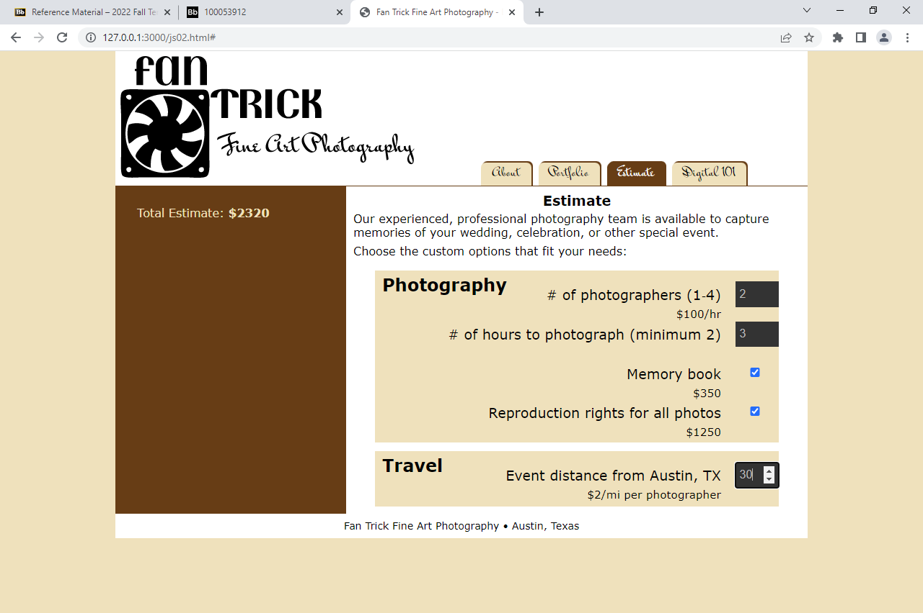

1. Add a screenshot of the **modified** js02.html file displayed in a browser showing total cost for a project using 3 photographers working 4 hours and travelling 35 miles.

